1. Suppose you have a dataset containing daily temperature readings for a city, and you want to identify days with extreme temperature conditions. Find days where the temperature either exceeded 35 degrees Celsius (hot day) or dropped below 5 degrees Celsius (cold day).

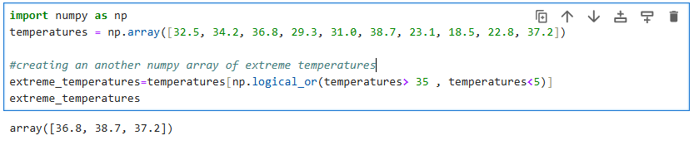

2. Suppose you have a dataset containing monthly sales data for a company, and you want to split this data into quarterly reports for analysis and reporting purposes.

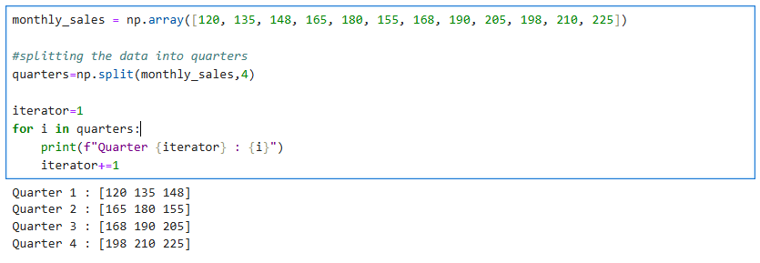

3. Suppose you have a dataset containing customer data, and you want to split this data into two groups: one group for customers who made a purchase in the last 30 days and another group for customers who haven't made a purchase in the last 30 days.

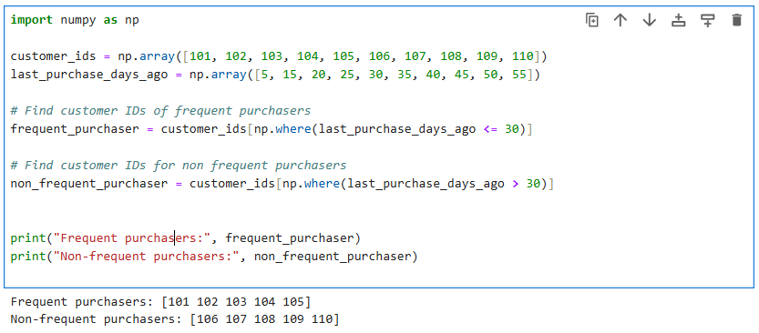

4.Suppose you have two sets of employee data—one containing information about full-time employees and another containing information about part-time employees. You want to combine this data to create a comprehensive employee dataset for HR analysis.

